Enrolling users to a category

* Go to the category into which you wish to enrol users. **Note:** You need to have category rights (manager or administrator)
* In the *Administration* block,click *Assign roles*. The list of possible roles you can assign will appear:

[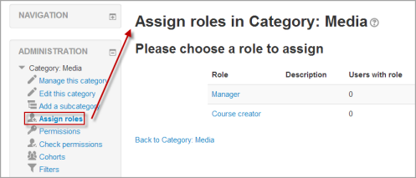](https://docs.moodle.org/31/en/File:Categoryassign.png)

**NOTE:** The roles you see here are roles which have been assigned at the category context and which you are able to assign i.e. the role has been checked in *Site administration > Accounts > Users > Permissions > Define roles > Allow role assignments.*